Presentation Notes
https://uregina-my.sharepoint.com/:p:/r/personal/lerminis_uregina_ca/_layouts/15/Doc.aspx?sourcedoc=%7BF3310D1A-FF4C-44F7-B6F2-AAF8D46F1C1C%7D&file=372Slides.pptx&action=edit&mobileredirect=true

Start with talking about project report
- Talk about scope, title, name of group, name of project, languages used, database (show mysql tables)
- Why did you choose to create a project on this website
- Demonstrate the system last, show validation code, make new user, etc.
- Show snippets of how code implemented?
- Talk about different users; admin, guest, registered
- Show diagrams??? List classes used, use case diagrams, etc.
- Describe how actions are being taken (show how a user is reported in code)

“Create a formal presentation” “use slides”
Not everyone has to present :]
What model did we use? Waterfall

Focus on the process, not the system
> how do you design ur problem
> how do you model ur problem
> how did u manage the project? Complexity? What was difficult?

Structure of Presentation

- (Mahrs) Intro
- (Stephen) Problem Definition (talk about 215 website and how we made improvements)
  - Waterfall model
  - Management
  - How we managed: google docs, hercules, scheduling sit down meetings

- (Armaan) Main design considerations + three main uses cases + diagrams (different type of users)

- (Armaan) Object Diagram, class diagram
- (Armaan) Component diagram,
  - We used the component diagram to help us visualize the flows through a model
  - Describe it
  - This will be apparent when we demonstrate the website

- (Mahrs) class list + technical considerations + mysql database + example
- (Shannon) Testing
- (Mathew) Product demonstration
- (Stephen) What what we got out of this - problems we faced, limitations, if we were to do this again we’d host our own server, we needed mathew for main point of contact

1. (Stephen/Mahrs ) (1pts) Problem definition.

` Our customers requested a web application which behaves as a social media platform where users can create, view, and vote on posts. Ideally, our users would be able to create an account and be able to manage their profile and posts. Users can then communicate with their friends and share ideas on this platform.

2. (Stephen/Mahrs)(3pts) Software requirements specification document, including: a. For each type of users, the use case diagram with all the use cases (consistent and unambiguous functional requirements) and actors. b. Define in detail three use cases (the most complex ones). c. Software qualities (correctness, efficiency, robustness and user friendliness).

2.1 Use Case Diagram
Link:https://online.visual-paradigm.com/diagrams.jsp#diagram:proj=0&type=UseCaseDiagram&gallery=/repository/514b156d-0257-4a05-bf77-1636e1c0815b.xml&name=Use%20Case%20Diagram%20Template
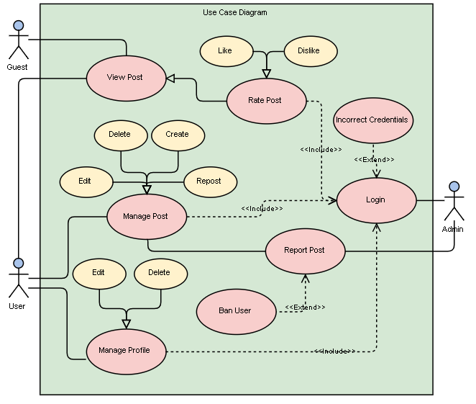
2.2 Main Use Cases

- Creating a post: Users who are logged in can create a post with a maximum of 250 characters and have it displayed on the post list page. A dynamic counter character is used to display the number of characters that have been written. Users are not permitted to submit the post if they exceed the limit and are provided with an error message. Created posts have both front-end and back-end validation to prevent security issues.

- Viewing a post: The created posts are displayed on the post list page. Users are redirected to the post list page after a successful login. Users are able to view the most recent 20 posts on each page, and are able to click “Next Page” button to view older posts. Users can also click on a user to see the posts that have been created by that poster. Further, the profile image for each poster is displayed beside the post message.

- Reporting a post: Users have the ability to like or dislike a post by clicking on the appropriate button. Counters for the number of likes and dislikes are visible on the associated post. The page is refreshed every time a user likes or dislikes a post.

- A user reports a post, click report button
- Admin can view report list button to perform an action (banning, deleting, ignoring)
- Banning a user makes them unable to login, deletes post associated

2.3 Software Qualities

Privacy - secure user details behind login
Portability - responsiveness to different screen sizes, supported on all browsers except Internet Explorer
Input Validation - login registration, post length
Scalability - supports TBD number of users, posts of 255 character length, sufficient server size
Safety - blocking users, prevent web attacks
Usability - consistent post refreshing with AJAX, quick response time, updating profile details, website design
Documentation - code, outside of code documents, error log for support team,
Maintainability - inline comments, reuse of code, user feedback, necessary
modifications to database
Availability - dependent on Hercules uptime
Correctness -
Efficiency -
Number of clicks to do something, efficient way to ban user
Robustness -

User friendliness -

3. (Armaan) (5pts) Design specification document, including: a. Software architecture (multi-layer architecture). b. Three sequence diagrams (for the three defined use cases). c. Class diagrams with all the classes and their relationships. d. Two examples of object diagrams
A. 3 Tier Architecture:
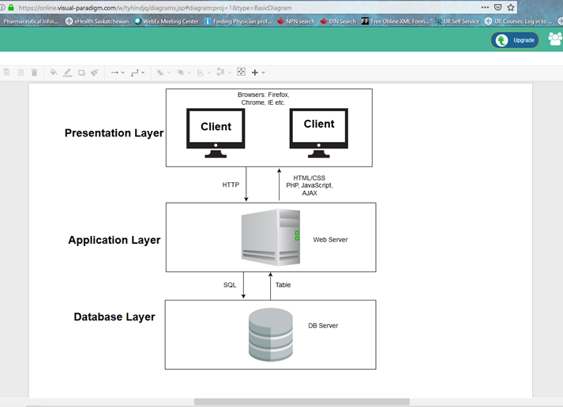

B. Three sequence diagrams (for the three defined use cases):
1. Creating a post:
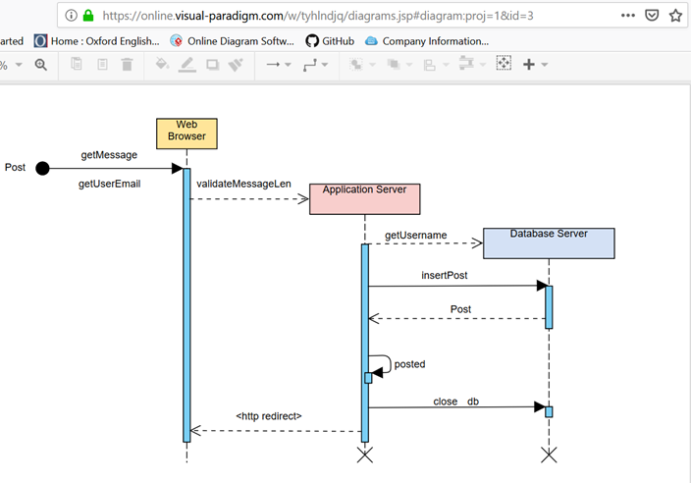
2 Viewing posts:
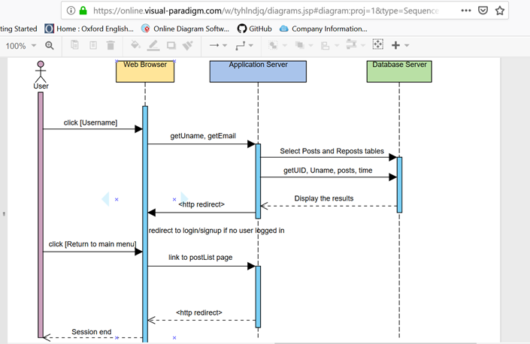

3: Reporting on a post:
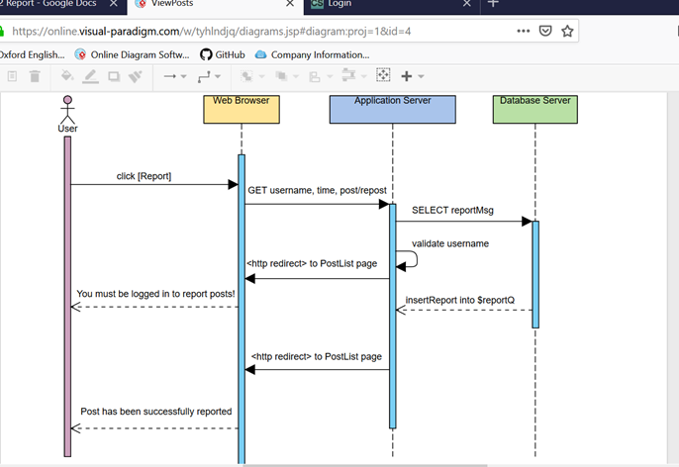

C. Class diagrams with all the classes and their relationships:
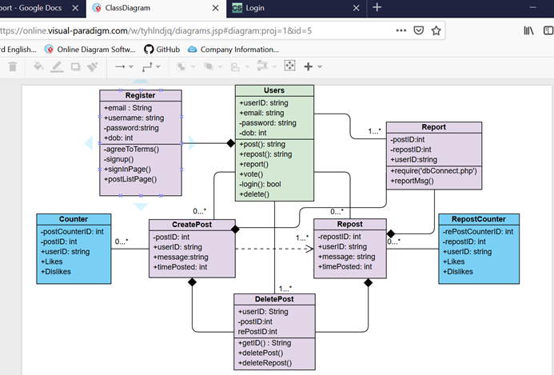
D. Two examples of object diagrams:
1. Login Process:
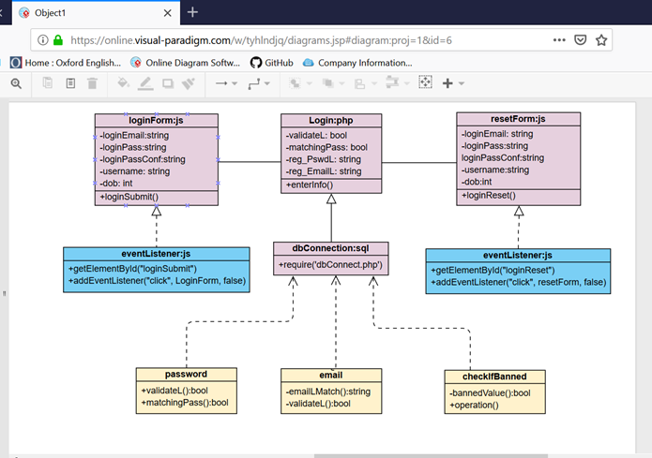
2. Registration/Creating a new account process:
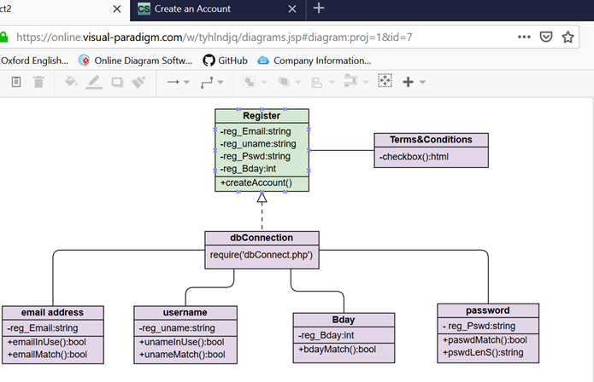

4. (4pts) Code description, including: a.(Mathew) Component diagrams regarding the organization of the source code. b. (Stephen) Deployment diagram regarding the hardware configuration of the software system (2 or 3 tiers). c.(Stephen) List the classes and functions that you have implemented. d. (Stephen) Include the link of your Web-based application.

4.1 Component Diagram
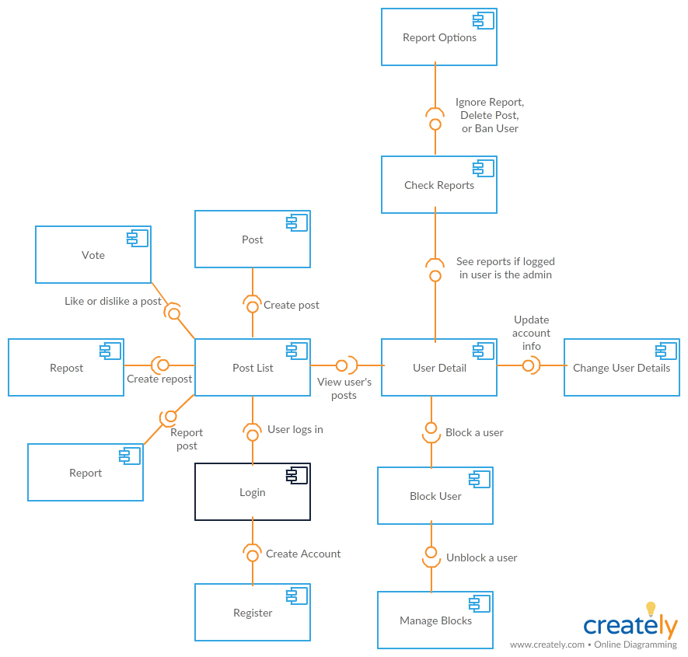

4.2 Deployment Diagram

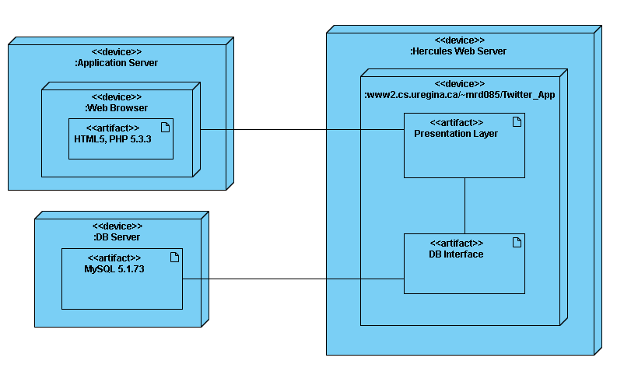

4.3 List of classes and functions that you have implemented

Class name | File Associated | Short Description
login | Login.php | Validates login actions, ensures correct format for inputs, sets session variable, etc.
register | Register.php | Validates register actions, ensures correct format for inputs, etc.
messages | displayMessages.php | Handles pulling posts from the database
sidebar | rightSide.php | Handles everything on the welcome screen once user is logged in
pageButtons | pageButtons.php | Handles switching between pages for every 20 posts
post | postClass.php | Handles the creation of posts and reposts
counter | counterClass.php | Handles increasing and decreasing the like/dislike counters
display | displayPosts.php | Handles displaying posts/reposts/reports on the PostList and UserDetail page (20 at a time).

4.4 Website URL:

http://www2.cs.uregina.ca/~mrd085/Twitter_App/PostList.php

5. (Mahrs) (3pts) Technical documentation, including: a. UML supporting tool. b. Programming languages. c. Reused algorithms and programs. Include their links. d. Software tools and environments. Indicate which software parts are using which tools. e. Database management system. Provide a screenshot of the table contents.

Technical Documentation
- The UML supporting tools that were used for this software project are:
- Visual Paradigm Online which is an online diagram editor that allows for collaboration with team members.
Source: https://online.visual-paradigm.com/
- Creately which is a visual collaboration platform that allows users to create flowcharts, UML diagrams, mind maps, and more.
Source: https://creately.com/

b. The programming languages that were used for this software project are:
- HTML (Hypertext Markup Language)
  - HTML5
  - XHTML1.1
- CSS (Cascading style sheets)
- PHP (Hypertext Preprocessor) - Server side script language
- JavaScript: Client-side script language
  - AJAX:Asynchronous JavaScript And XML
    - Note: AJAX is not a programming language but a tool that uses a browse built in XMLHttpRequest object with Javascript and HTML DOM to allow web pages to be updated asynchronously.
- SQL (Structured Query Language)

C. This software did not reuse any programs and algorithms.
D. The software environments that were used for this project are:
- Eclipse which is an open source Integrated Development Environment that was used to write, compile and edit HTML, PHP, JavaScript and CSS code for all pages of the website
- Atom which is an open source text and code editor that was used to write, compile and edit HTML, PHP, JavaScript and CSS code for all pages of the website
- Hercules which is a UNIX environment that was used to access, store and manage all HTML. PHP, JavaScript, CSS files and other necessary files for the project through a command-line interface
- PuTTy which is a terminal emulation program that was used to connect to Hercule’s Command-Line on Windows for use of Hercules in locations off campus
- WinSCP which is a SFTP and FTP client for Windows with a graphical user interface that was used to transfer files to and from Hercules

E. The database system that was used for this project is MySQL which implements
Structured Query Language.

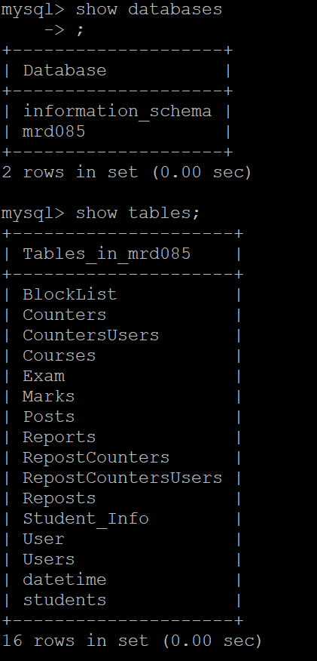
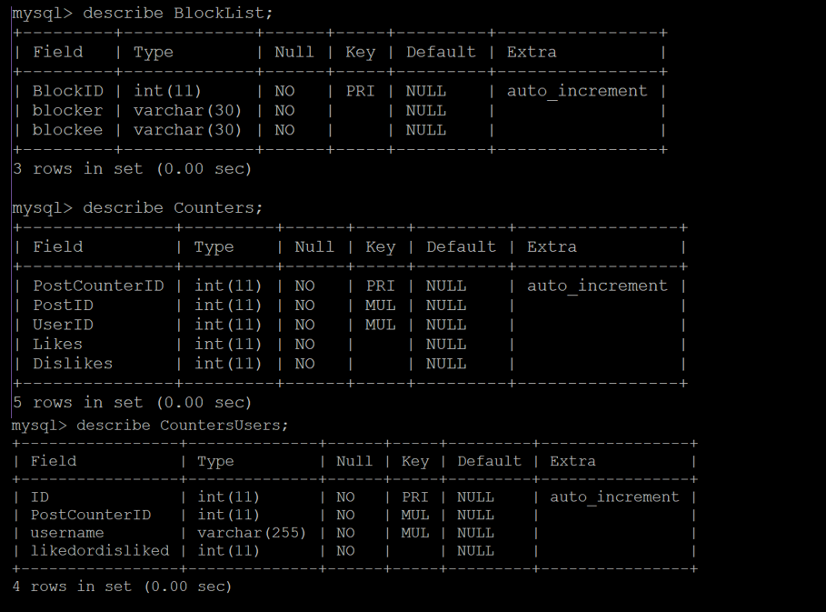

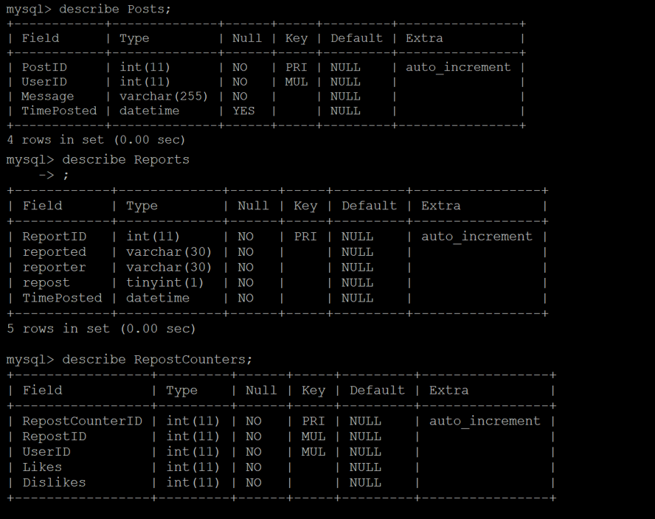
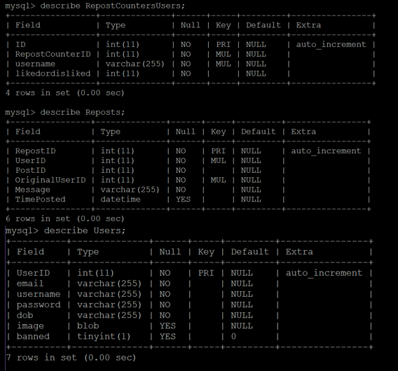

6. (Shannon) (1pts) User documentation including at least 8 different screen shots of the GUIs.

7. (Shannon) (3pts) Code testing, including: a. Correctness testing with five test cases. For each test case, submit the screenshots of the inputs and outputs. b. Robustness testing with five test cases. For each test case, submit the screenshots of the inputs and outputs. c. Performance testing with some benchmarks.
Five test cases:
- Correctness > can a user be created correctly, can a post be created, can you change user picture, can you see everyones post, can you dislike/like posts.
- Robustness > js validation, php validation, do other file formats break image upload, word limit on post (250 chars), auto-logout*

C. how many posts we can accomodate, how many users can we accommodate, does it work different browsers/different devices,

I

8. A document that clearly indicates the completed tasks of each member.

Do own part
Meetings,

